Written Multiplication- Questions

Key Stage 2: 2003 Paper A
1.
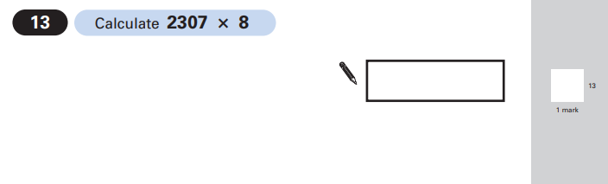
Key Stage 2: 2003 Paper B
1.
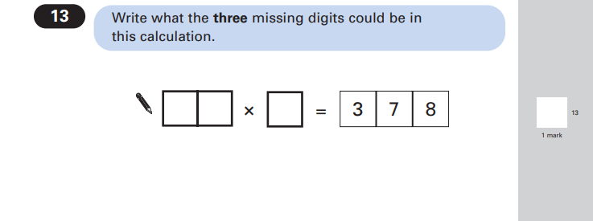
Key Stage 2: 2004 Paper A
1.
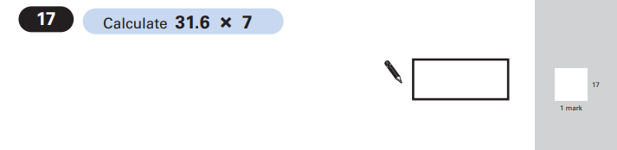

Key Stage 2: 2004 Paper B
1.
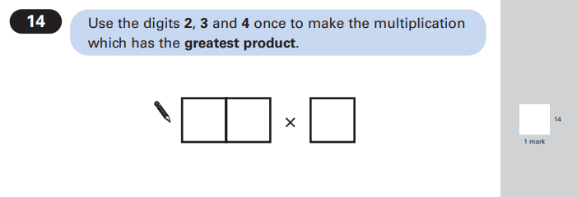
Key Stage 2: 2005 Paper A
1.
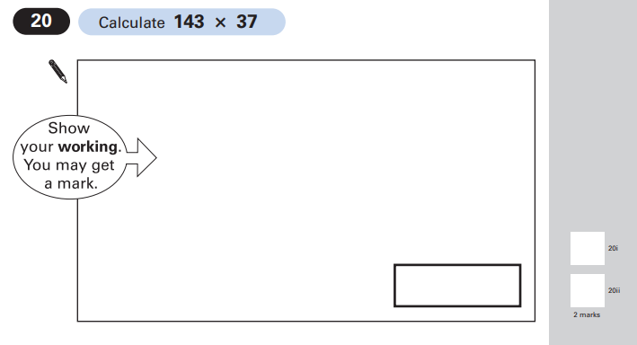

Key Stage 2: 2005 Paper B
1.
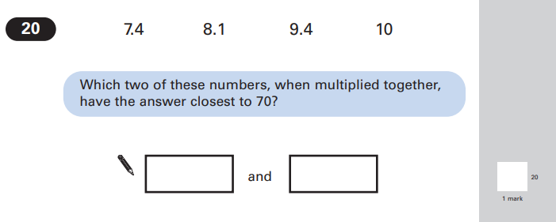
Key Stage 2: 2007 Paper A
1.
Key Stage 2: 2008 Paper A
1.
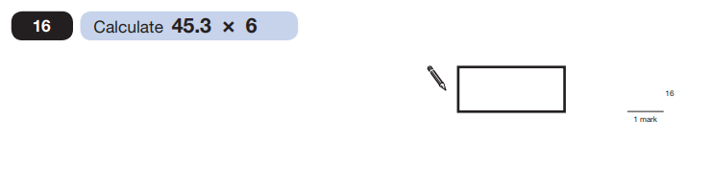

Key Stage 2: 2009 Paper A
1.
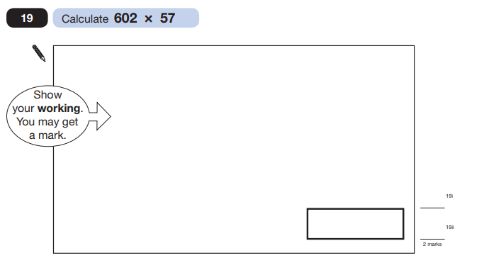
Key Stage 2: 2010 Paper A
1.
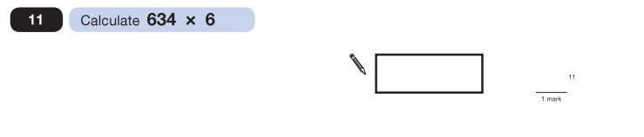

Key Stage 2: 2012 Paper A
1.
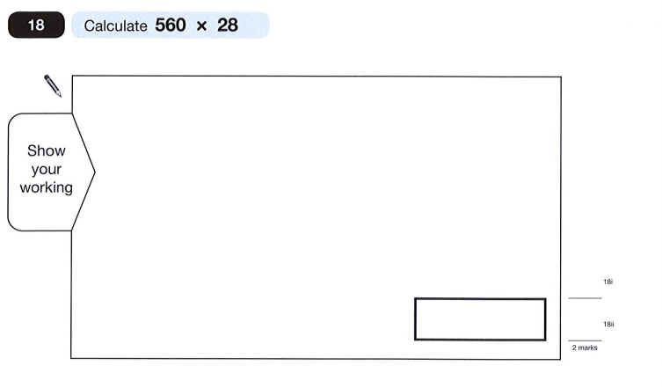
Key Stage 2: 2012 Paper B
1.
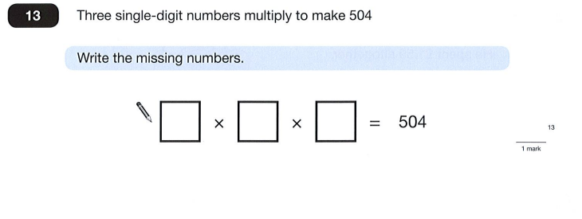

Key Stage 2: 2013 Paper A
1.
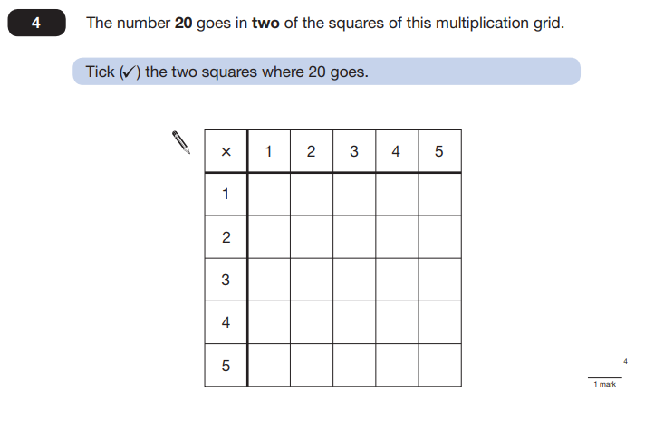
Key Stage 2: 2014 Paper A
1.
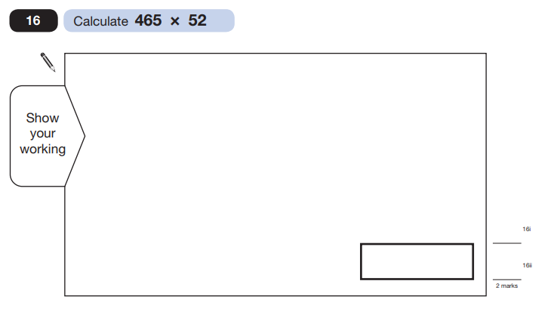

Key Stage 2: 2015 Paper A
1.
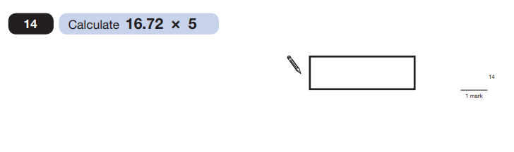
Key Stage 2: Paper 1 Arithmetic - Sample
1.
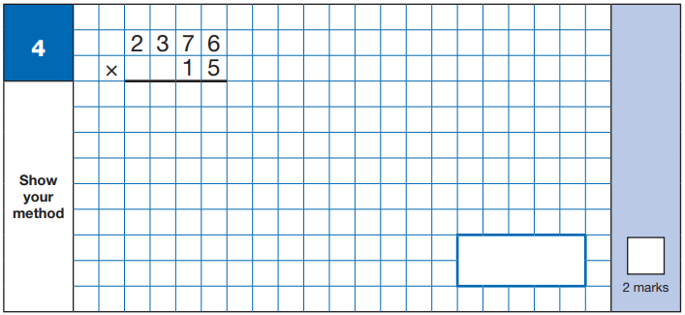

Key Stage 2: 2016 Paper 1 Arithmetic - Sample
1.
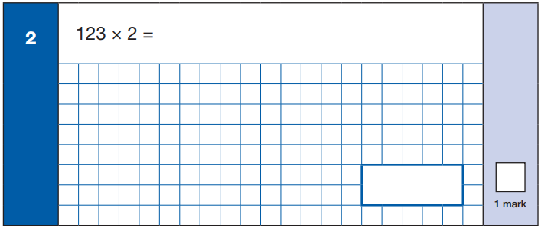
Key Stage 2: 2016 Paper 1 Arithmetic - Sample
2.
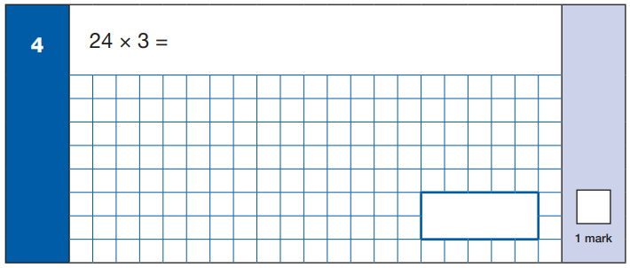

Key Stage 2: 2016 Paper 1 Arithmetic - Sample
3.
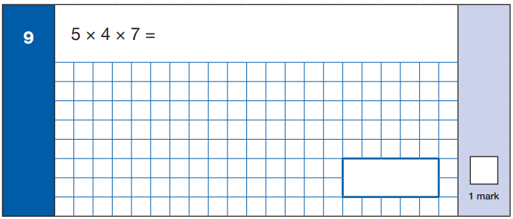
Key Stage 2: 2016 Paper 1 Arithmetic - Sample
4.
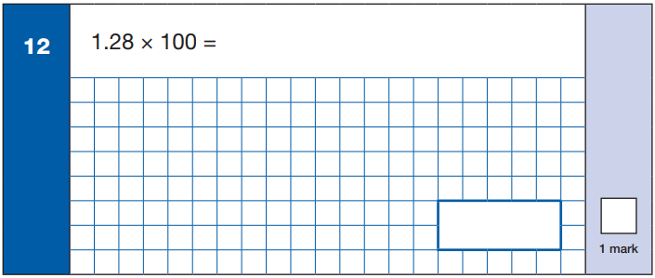

Key Stage 2: 2016 Paper 1 Arithmetic - Sample
5.
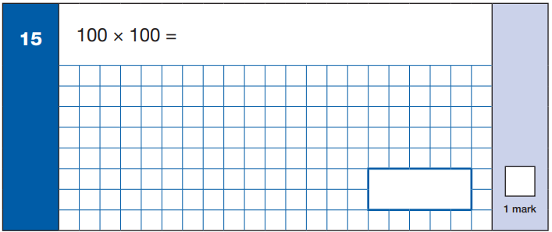
Key Stage 2: 2016 Paper 1 Arithmetic - Sample
6.
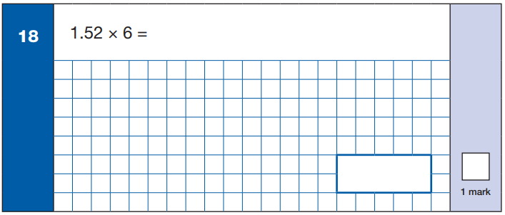

Key Stage 2: 2016 Paper 1 Arithmetic - Sample
7.
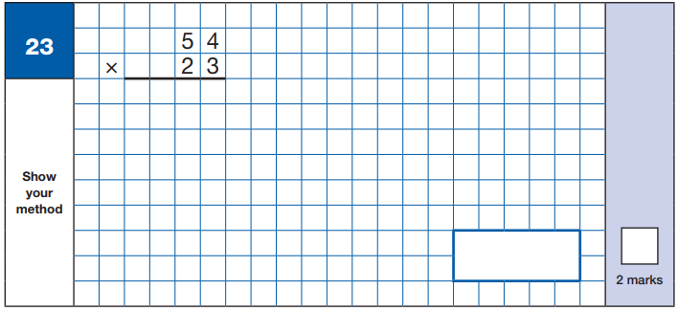
Key Stage 2: 2016 Paper 1 Arithmetic - Sample
8.
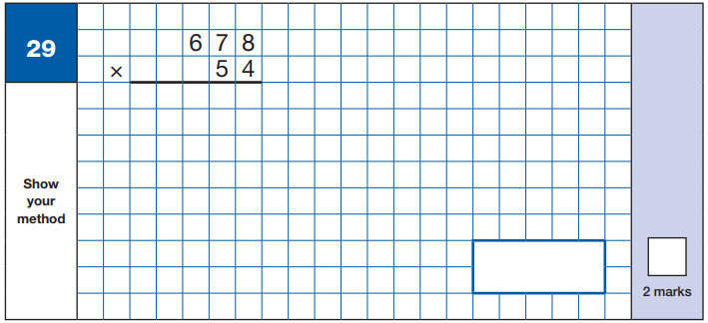

Key Stage 2: 2016 Paper 2 Reasoning - Sample
1.
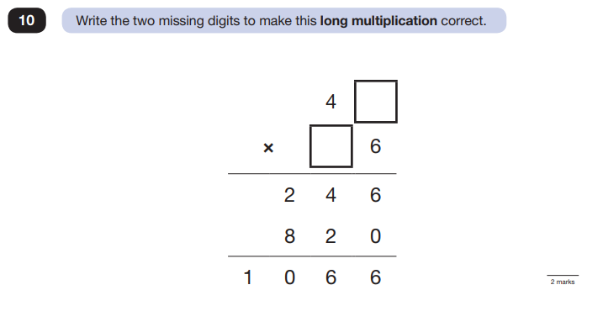
Key Stage 2: 2016 Paper 1 Arithmetic
1.
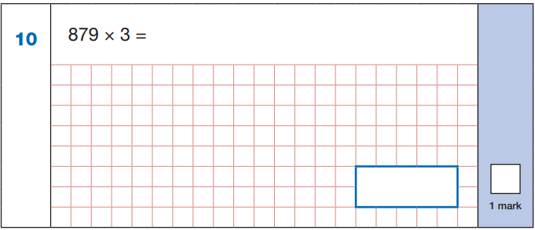

Key Stage 2: 2016 Paper 1 Arithmetic
2.
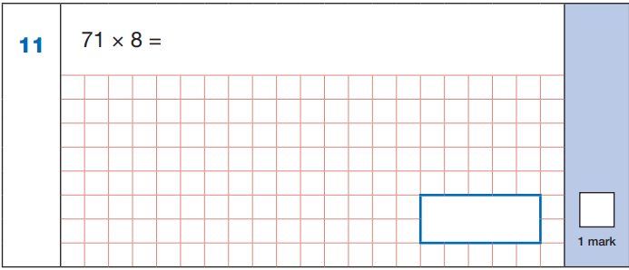
Key Stage 2: 2016 Paper 1 Arithmetic
3.
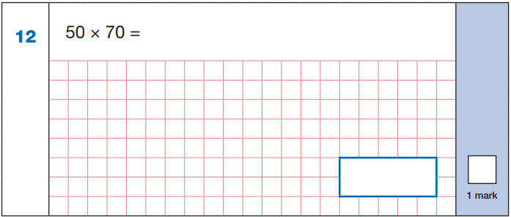

Key Stage 2: 2016 Paper 1 Arithmetic
4.
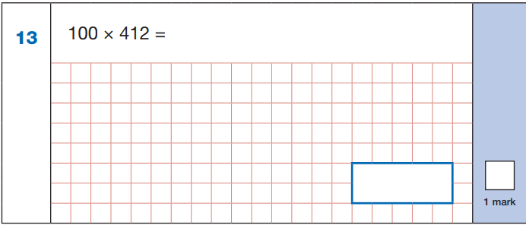
Key Stage 2: 2016 Paper 1 Arithmetic
5.
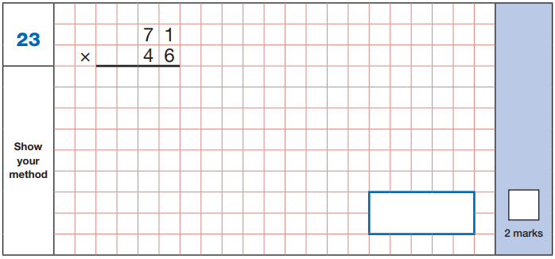

Key Stage 2: 2016 Paper 1 Arithmetic
6.
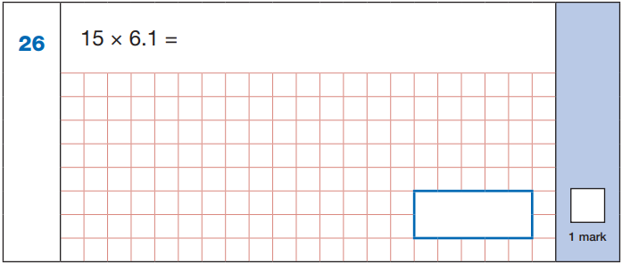
Key Stage 2: 2016 Paper 1 Arithmetic
7.
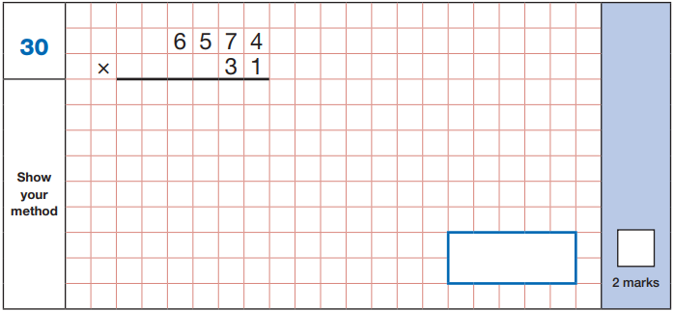
Key Stage 2: 2016 Paper 3 Reasoning
1.
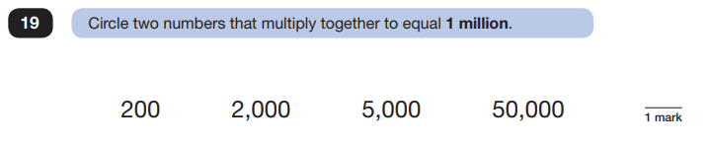

Key Stage 2: 2017 Paper 1 Arithmetic
1.
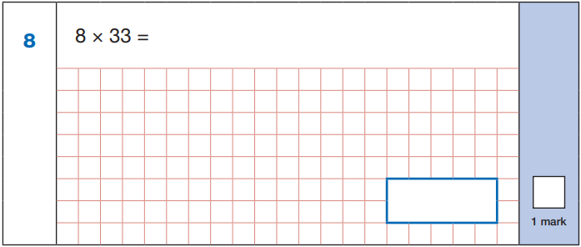
Key Stage 2: 2017 Paper 1 Arithmetic
2.
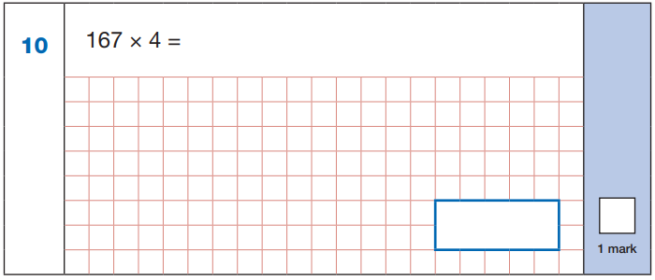

Key Stage 2: 2017 Paper 1 Arithmetic
3.
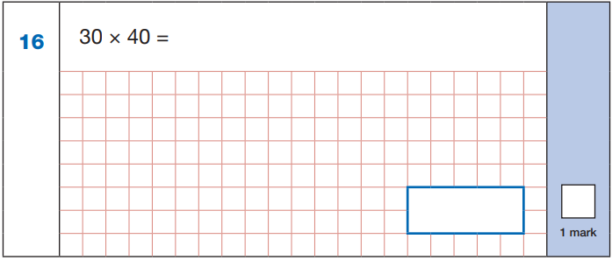
Key Stage 2: 2017 Paper 1 Arithmetic
4.
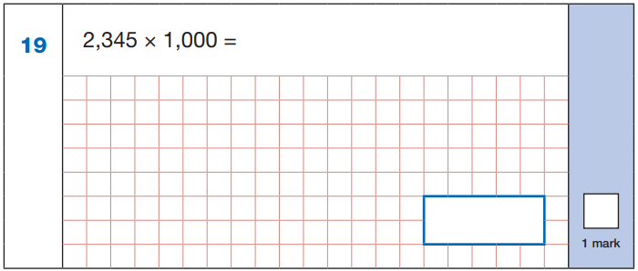

Key Stage 2: 2017 Paper 1 Arithmetic
5.
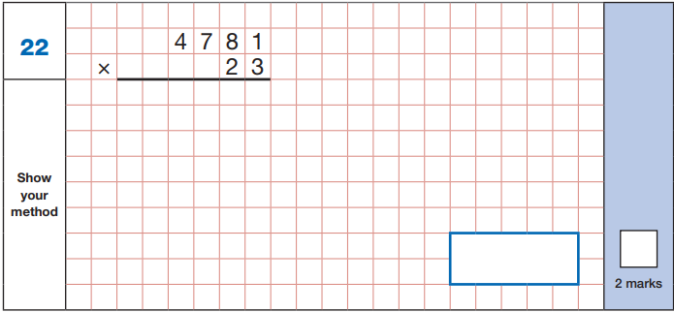
Key Stage 2: 2017 Paper 1 Arithmetic
6.
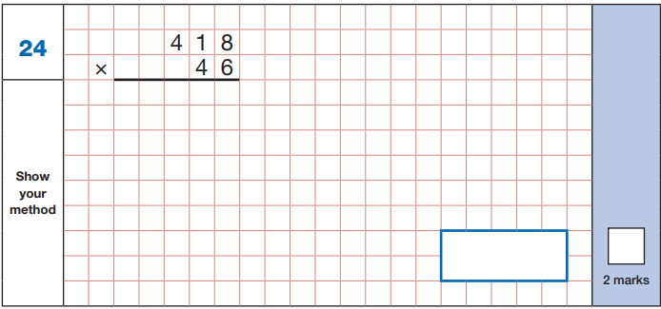

Key Stage 2: 2017 Paper 1 Arithmetic
7.
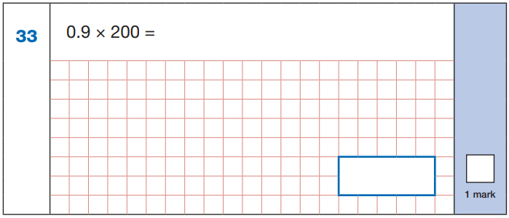
Key Stage 2: 2017 Paper 2 Reasoning
1.
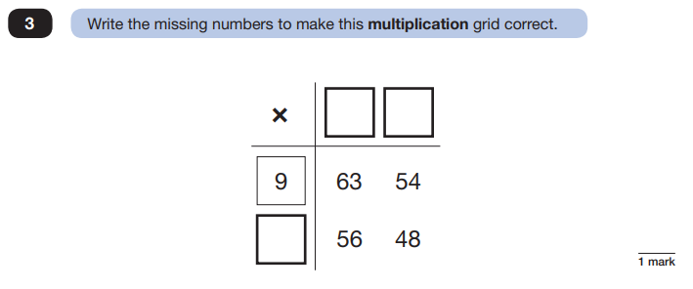

Key Stage 2: 2018 Paper 1 Arithmetic
1.
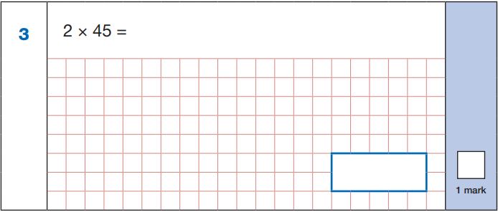
Key Stage 2: 2018 Paper 1 Arithmetic
2.
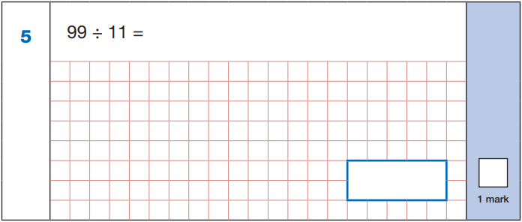

Key Stage 2: 2018 Paper 1 Arithmetic
3.
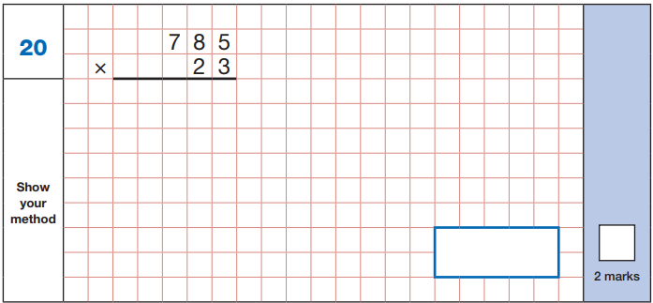
Key Stage 2: 2018 Paper 1 Arithmetic
4.
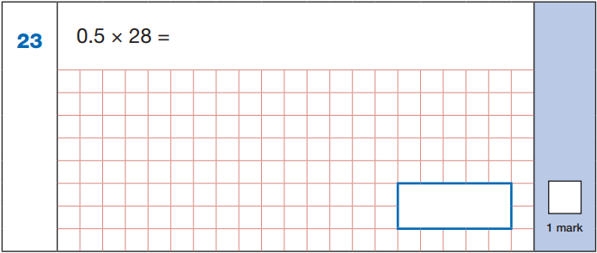

Key Stage 2: 2018 Paper 1 Arithmetic
5.
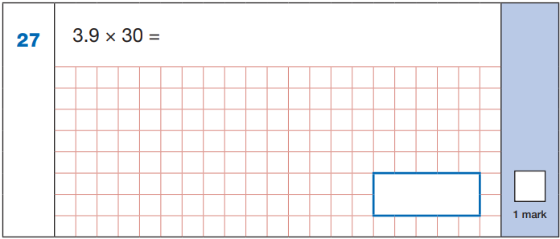
Key Stage 2: 2018 Paper 1 Arithmetic
6.
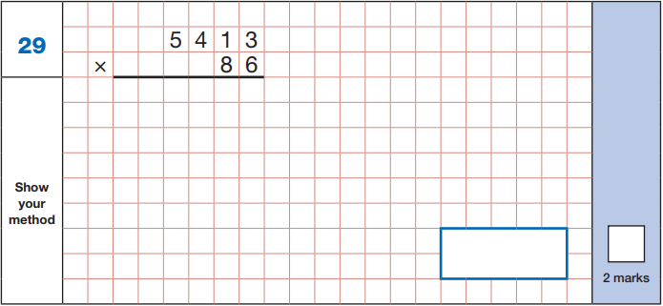

Key Stage 2: 2019 Paper 1 Arithmetic
1.
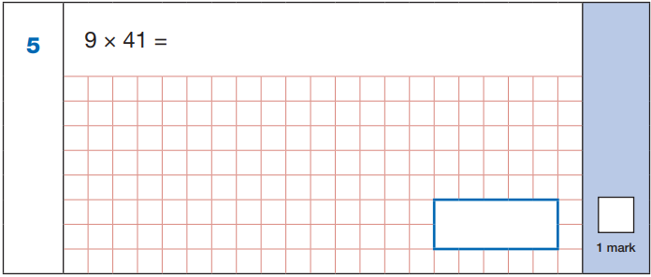
Key Stage 2: 2019 Paper 1 Arithmetic
2.
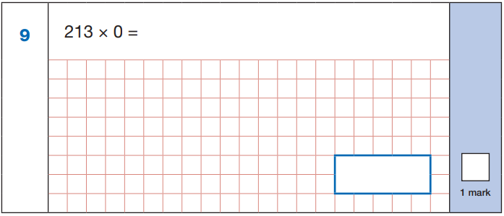

Key Stage 2: 2019 Paper 1 Arithmetic
3.
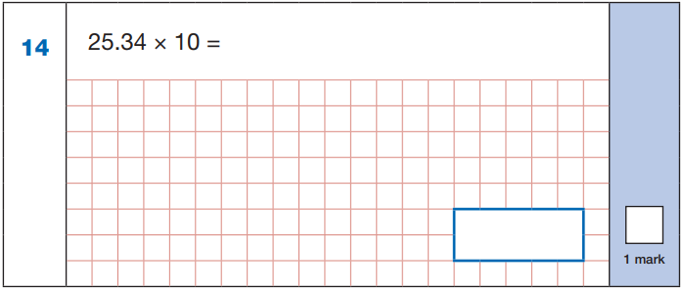
Key Stage 2: 2019 Paper 1 Arithmetic
4.
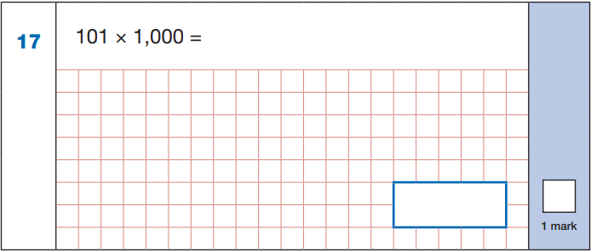

Key Stage 2: 2019 Paper 1 Arithmetic
5.
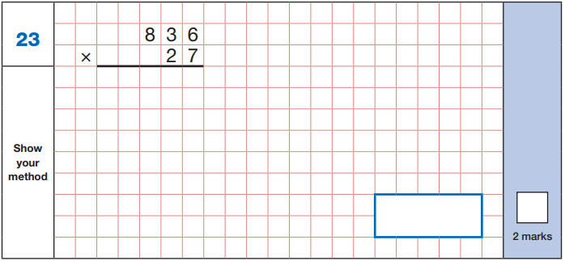
Key Stage 2: 2019 Paper 1 Arithmetic
6.
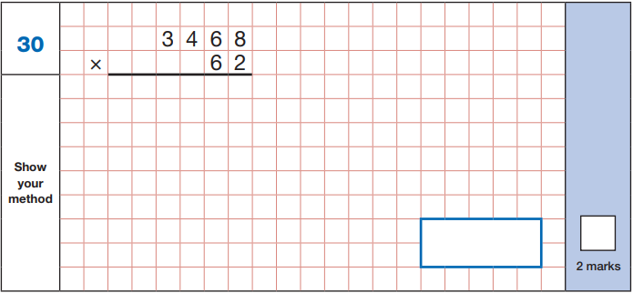

Key Stage 2: 2019 Paper 2 Reasoning
1.
